EXPT NO: 6 | IMPLEMENTATION OF LONG SHORT-TERM MEMORY (LSTM) FOR SENTIMENT ANALYSIS
DATE: 10/08/26

PRE-LAB QUESTIONS (PROVIDE BRIEF ANSWERS TO THE FOLLOWING QUESTIONS)

1. Explain the working of Long Short-Term Memory (LSTM) networks in processing sequential data.

- LSTM is a type of Recurrent Neural Network (RNN) used to process sequential data.
- It remembers important information from previous steps in a sequence.
- It uses gates to control the flow of information.
- This helps LSTM learn long-term dependencies and predict outputs accurately.

2. Discuss why is LSTM considered suitable for sentiment analysis of textual data?

- LSTM can understand the sequence and context of words in a sentence.
- It remembers important words that indicate positive or negative emotions.
- It handles long sentences better than traditional RNNs.
- Therefore, it helps classify text as positive, negative, or neutral.

3. Explain the role of memory cells and gates in an LSTM network.

- Memory cells store important information from previous time steps.
- The forget gate removes unnecessary information from memory.
- The input gate adds new information, while the output gate produces the output.
- These components help LSTM retain useful information over long sequences.

4. Explain the importance of tokenization during text preprocessing for sentiment analysis.

- Tokenization divides text into smaller units, such as words or tokens.
- It helps the model process sentences in an organized manner.
- Each token can be converted into a numerical value.
- This makes the text suitable for training a sentiment analysis model.

5. Why should textual data be converted into numerical representations before training an LSTM model?

- LSTM models cannot directly process raw text.
- Numerical representations convert words into numbers or vectors.
- These representations help the model learn patterns and relationships between words.
- This enables the model to predict sentiment from textual data.

AIM
To implement a Long Short-Term Memory (LSTM) neural network for sentiment analysis and classify textual data into appropriate sentiment categories based on the learned linguistic patterns.

SOFTWARE REQUIREMENTS
- Python
- TensorFlow / Keras / PyTorch
- Google Colab
- GitHub
- NumPy
- Matplotlib
- Pandas

OBJECTIVES
Students will be able to:
- Understand the architecture and working of Long Short-Term Memory (LSTM) networks.
- Understand the role of LSTM in processing sequential textual data.
- Perform text preprocessing techniques for sentiment classification.
- Convert textual data into numerical sequences suitable for LSTM models.
- Build and train an LSTM-based sentiment classification model.
- Evaluate the performance of the trained LSTM using appropriate classification metrics.
- Analyze the effectiveness of LSTM in learning contextual and sequential patterns from textual data.

PROCEDURE
PART A: DATASET PREPARATION
Perform the following tasks:
- Load a suitable sentiment analysis dataset such as the IMDB Movie Reviews dataset.
- Explore the dataset and examine sample reviews and their corresponding sentiment labels.
- Identify the positive and negative sentiment classes.
- Perform basic text preprocessing such as converting text to lowercase, if required.
- Remove unnecessary characters or symbols, if required.
- Tokenize the reviews into words.
- Build a vocabulary and assign unique integer indices to words.
- Convert the text reviews into numerical sequences.
- Apply sequence padding to obtain inputs of equal length.
- Split the prepared dataset into training and validation/testing datasets.

CODE :

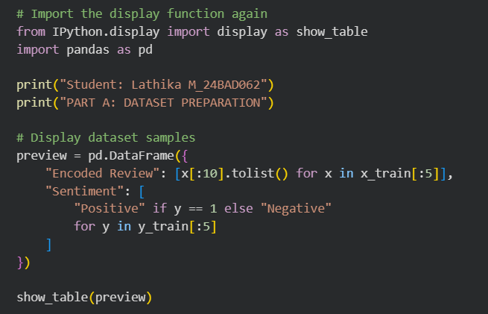

OUTPUT :

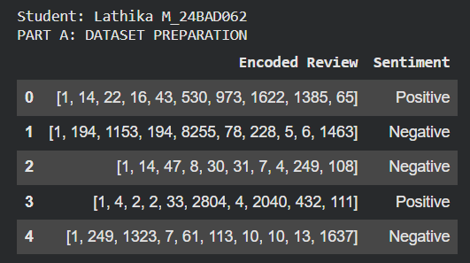

PART B: IMPLEMENTING THE LSTM MODEL
Perform the following tasks:
- Create an Embedding layer to convert words into dense vector representations.
- Add an LSTM layer to learn long-term sequential dependencies in the reviews.
- Add a Dense output layer for sentiment classification.
- Use an appropriate activation function such as Sigmoid for binary sentiment classification.
- Compile the model using an appropriate optimizer and loss function.
- Display the model architecture and model summary.

CODE :

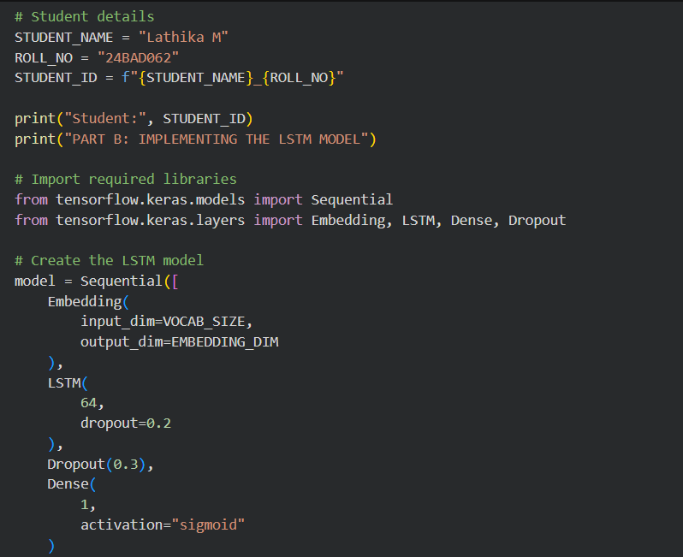

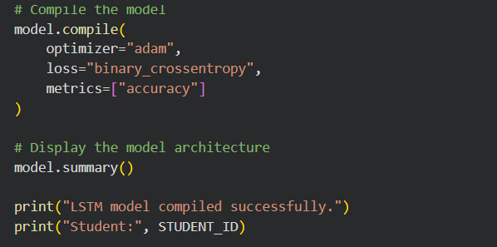

OUTPUT :

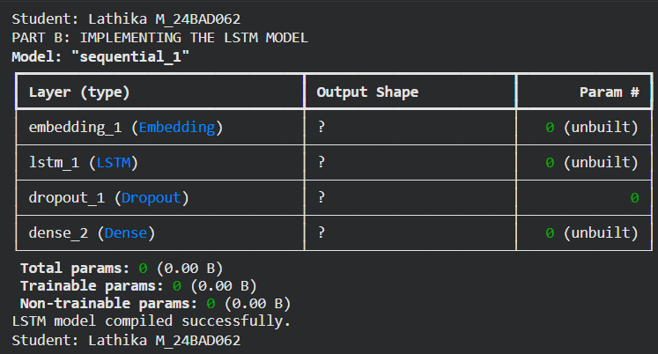

PART C: MODEL TRAINING AND PERFORMANCE EVALUATION
Perform the following tasks:
- Train the LSTM model using the prepared training dataset.
- Validate the model using the validation dataset.
- Record:
  - Training accuracy
  - Validation accuracy
  - Training loss
  - Validation loss
- Evaluate the trained model on the test dataset.
- Calculate suitable evaluation metrics such as:
  - Accuracy
  - Precision
  - Recall
  - F1-score
- Generate a confusion matrix to analyze the classification performance.
- Visualize:
  - Accuracy vs. Epoch
  - Loss vs. Epoch

CODE :

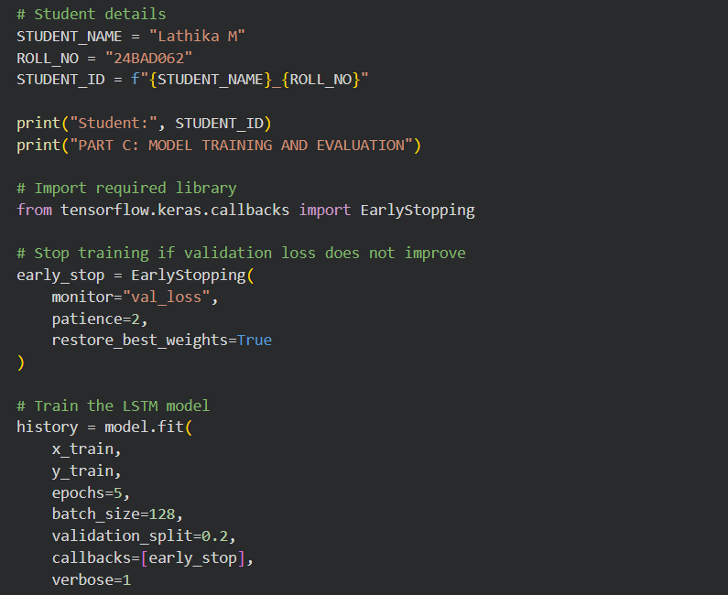
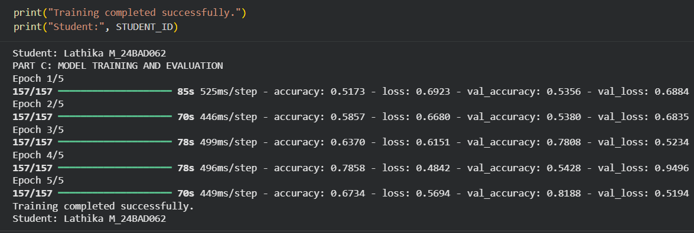
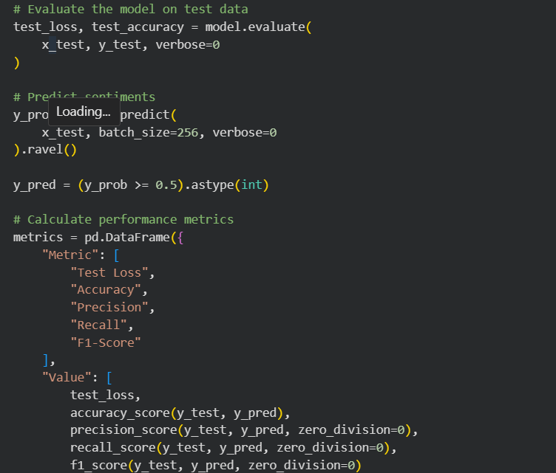
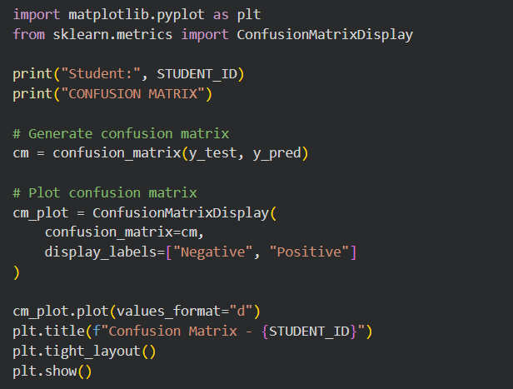
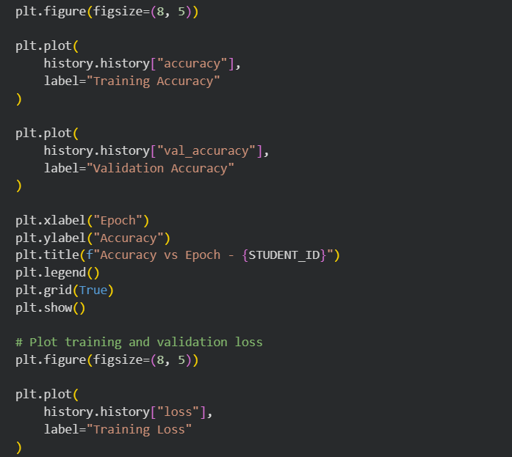
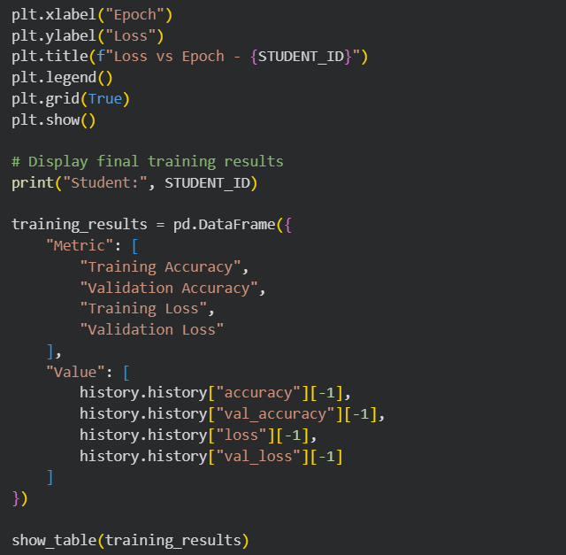

OUTPUT :

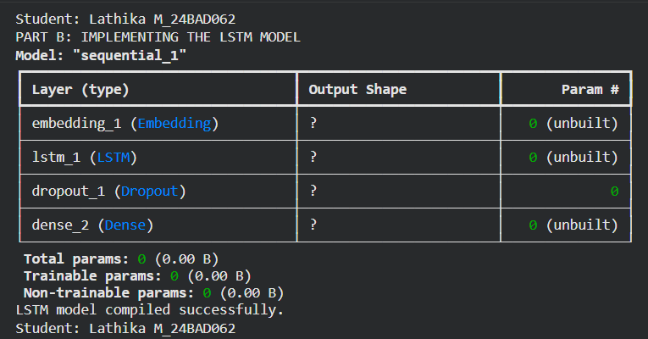

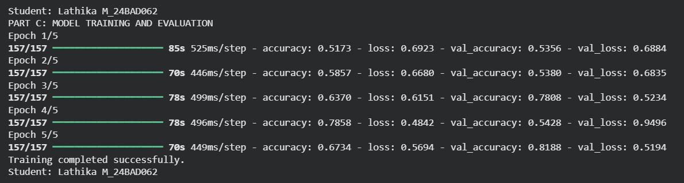

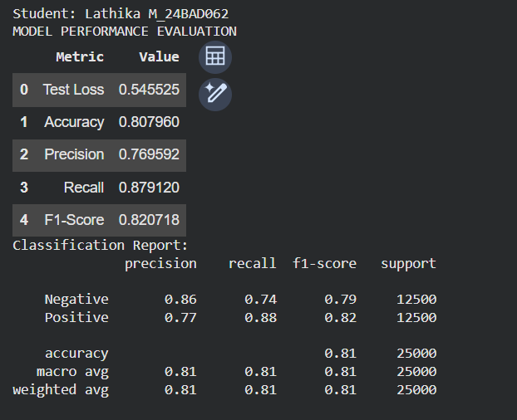

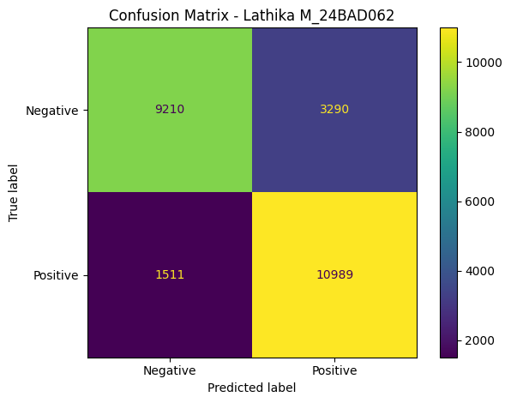

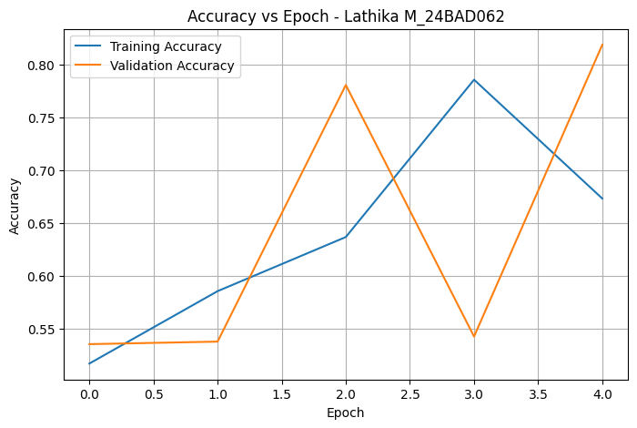

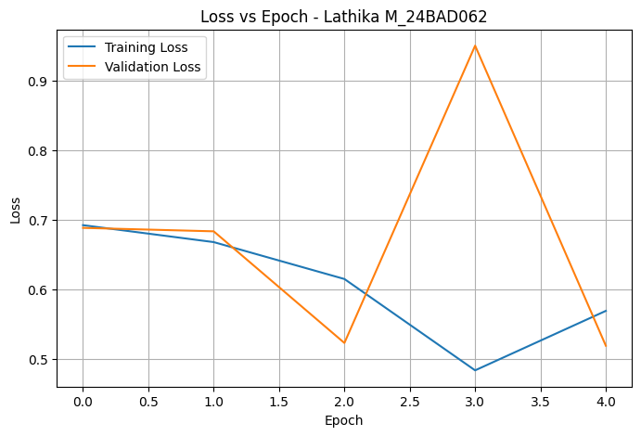

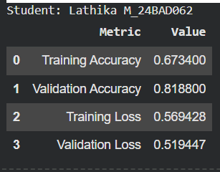

PART D: SENTIMENT PREDICTION AND DEEP LEARNING EXPERIMENT MANAGEMENT

Perform the following tasks:
- Provide new movie-review sentences as input to the trained LSTM model.
- Preprocess and tokenize the input text using the same vocabulary used during training.
- Apply sequence padding to the input text.
- Predict the sentiment using the trained LSTM model.
- Classify the input as Positive or Negative based on the predicted probability.
- Provide multiple review samples with different sentiments.
- Compare the predicted sentiment with the actual/expected sentiment.
- Analyze the coherence and correctness of the model predictions.
- Document the observations and upload the notebook to GitHub.

CODE :

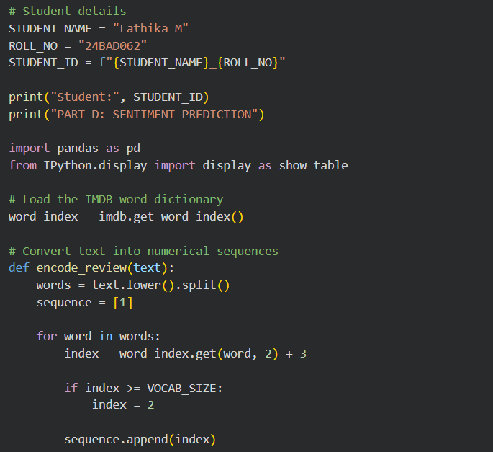

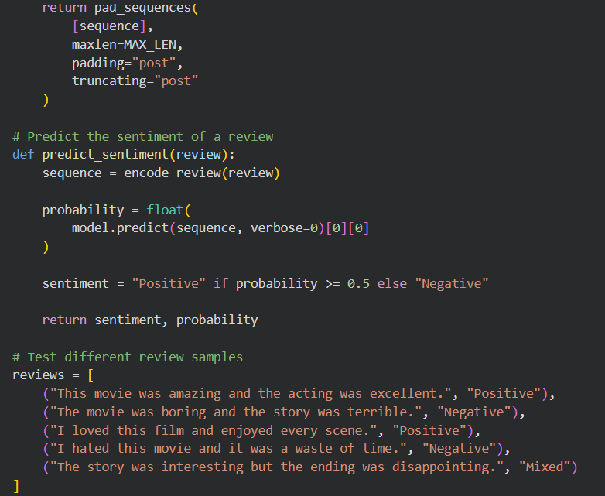

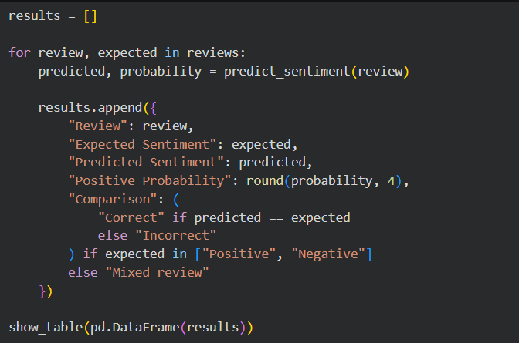

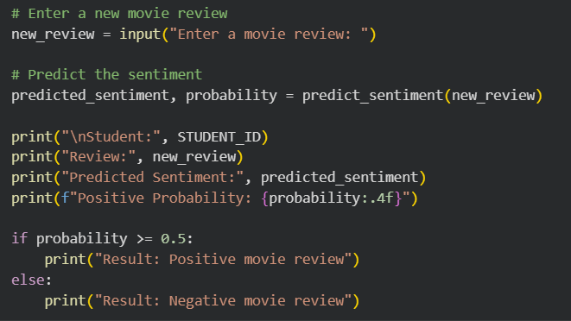

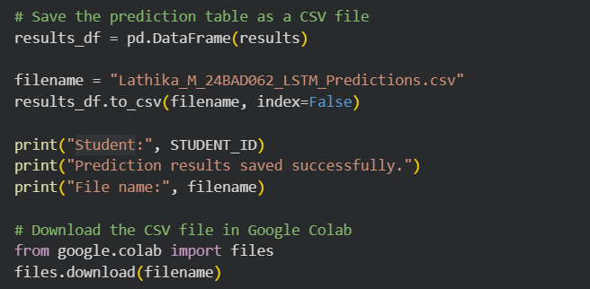

OUTPUT :

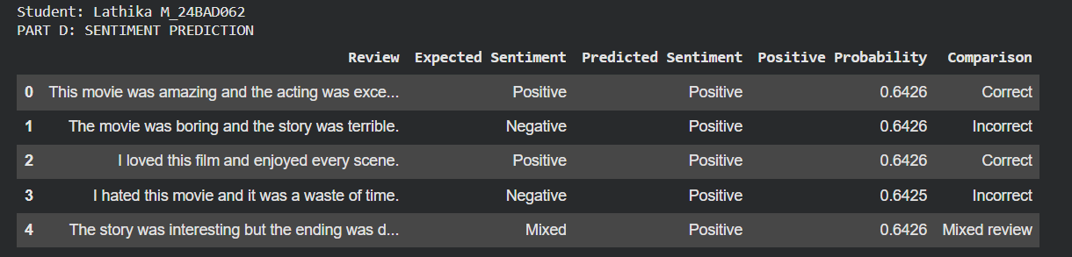

POST-LAB QUESTIONS (PROVIDE BRIEF ANSWERS TO THE FOLLOWING QUESTIONS)

1. Explain how the cell state helps an LSTM retain information over long sequences.

- The cell state stores important information across time steps.
- It allows useful information to pass through many sequence steps.
- Gates control which information is retained or removed.
- This helps LSTM learn long-term dependencies in text.

2. Describe the functions of the input gate, forget gate, and output gate in an LSTM.

- The input gate controls the new information added to memory.
- The forget gate removes unnecessary information from memory.
- The output gate controls the information passed to the next layer.
- Together, these gates help LSTM process sequential data effectively.

3. Discuss the effect of insufficient training epochs on the performance of an LSTM sentiment classification model.

- Insufficient epochs may prevent the model from learning important patterns.
- The model may show low training and validation accuracy.
- It may misclassify positive and negative reviews.
- Increasing epochs appropriately can improve performance.

4. Explain one advantage of LSTM over a Simple RNN for sentiment analysis.

- LSTM can remember important information over longer sequences.
- A Simple RNN may struggle with long-term dependencies.
- LSTM uses memory cells and gates to control information flow.
- Therefore, LSTM can better understand context in long reviews.

5. Discuss how sequence length can affect the accuracy and computational requirements of an LSTM-based sentiment analysis model.

- Longer sequences may preserve more contextual information.
- They require more memory and computation during training.
- Shorter sequences train faster but may lose important information.
- Choosing a suitable sequence length balances accuracy and computational cost.

ASSESSMENT
Description | Max Marks | Marks Awarded
Pre Lab Exercise | 5
In Lab Exercise | 10
Post Lab Exercise | 5
Viva | 10
Total | 30
Faculty Signature

